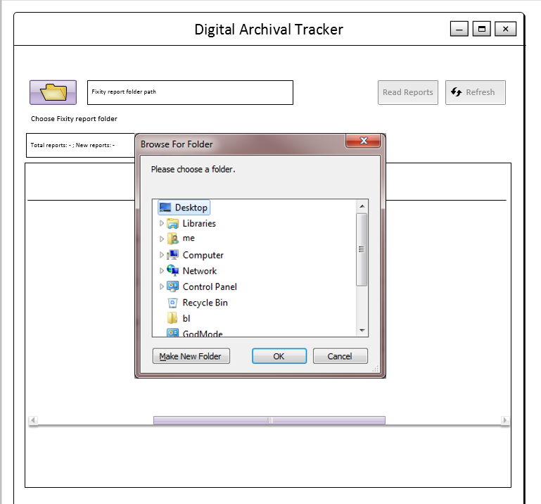

Fig 1: Choose Folder

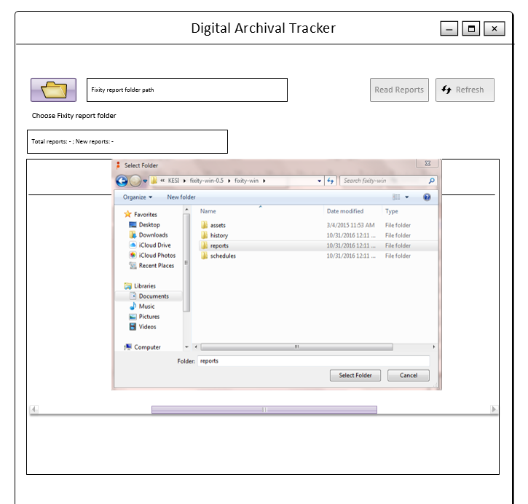

Fig 2: Choose folder and confirm.

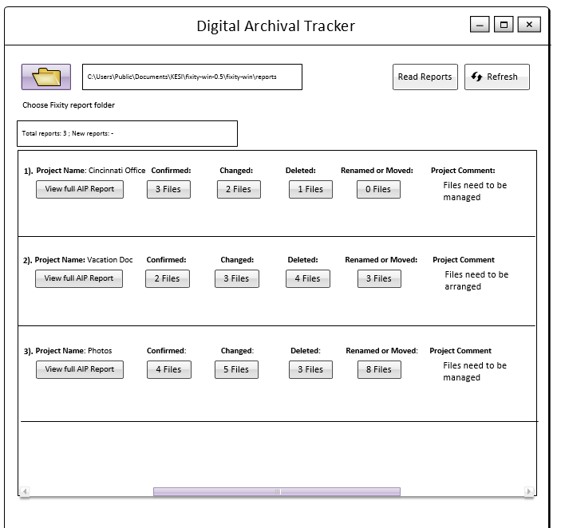

Fig 3: List view of all the project reports read.

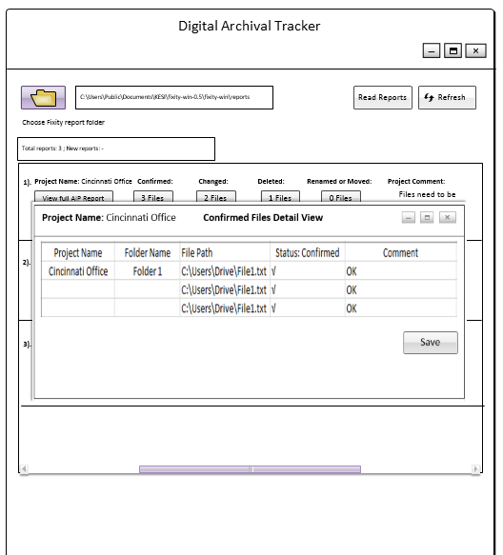

Fig 4: Confirmed Files Detailed View.

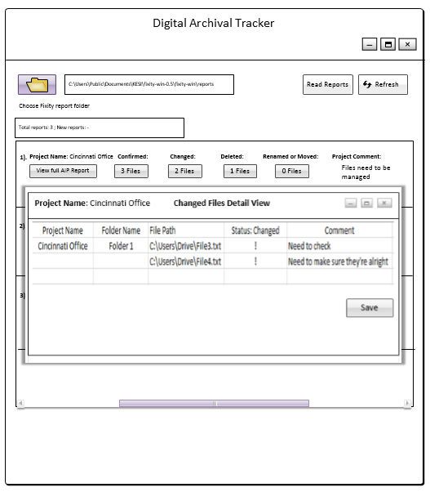

Fig 5: Changed Files Detailed View.

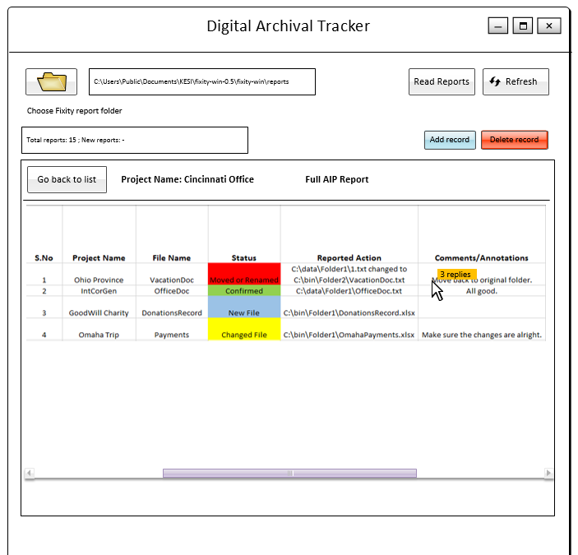

Fig 6: Full AIP Report 1.

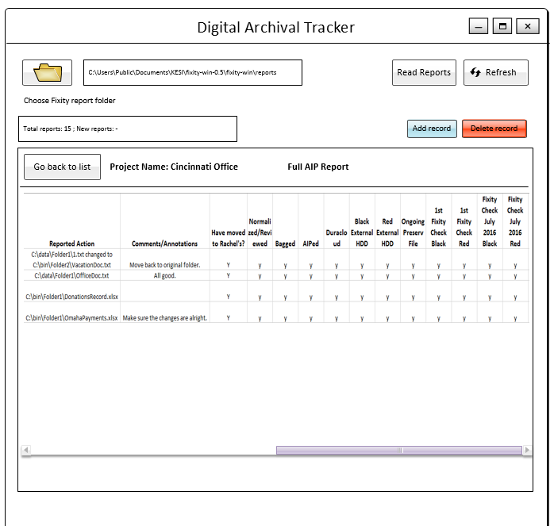

Fig 7: Full AIP Report 2.